Part 1
Nurturing Positive Values and Attitudes in 21st Century Learners

  - Promoting Values Education through English Sayings of Wisdom in Schools

Values education aims to cultivate in students positive values and attitudes and provide them with all-round learning experiences conducive to their whole-person development. Values education can be strengthened through the use of a wide array of learning and teaching resources which provide contexts for students to explore a variety of value-laden issues and stimuli for critical and imaginative responses. One fertile source of learning resources for fostering positive values and attitudes is sayings of wisdom (SOW). SOW, which include proverbs, quotes, maxims and adages, are words that provoke thinking, share insights and experience, and explore meaning in life. They are concise, easy to remember and relevant to students’ everyday life. They are not only melodic and witty, but are also characterised by brevity and they provide room for different interpretations of meaning.

Appreciating the meaning and beauty of the sayings can be uplifting and inspiring to students of all year levels. As students visualise, conceptualise and share their own understandings about the SOW, be it in the form of art, poetry, prose or other means, their creativity and communication competence are enhanced. Through exploring and appreciating the beauty of SOW, students will be enlightened by the cultural knowledge and the teachings embedded in the words of wisdom, and their language awareness and literacy skills will be enhanced by analysing the literary techniques (e.g. rhyme, alliteration, puns, assonance) used in the sayings. Opportunities abound for teachers to make use of these literary gems as a vehicle for nurturing positive values and attitudes in students and enriching their English learning experiences.

  - Holistic Planning of the School Curriculum for

Integrating Values Education into the School English Language Curriculum

Schools are encouraged to promote values education through providing holistic learning experiences in the school curriculum. The following provides some strategies and examples for English Language curriculum leaders to organically integrate values education into the school English Language curriculum. Given the cross-curricular nature of values education and the whole-school approach that it requires, schools are encouraged to synergise the efforts of teachers of different Key Learning Areas and functional groups as well as stakeholders in teaching, discussing, modelling and practising different positive values and attitudes.

A P3 textbook unit is identified to connect English learning and values education while taking into consideration the school mission, context and students’ needs.
Connecting the ten priority values and attitudes with the themes and topics of teaching modules/units in the English Language curriculum
Ten priority values and attitudes
Care for Others
Commitment
Diligence
Empathy
Integrity
Law-abidingness
National Identity
Perseverance
Respect for Others
Responsibility
Example
Strategy
Module
Animal Protection
Connection with the school motto
Be a responsible and committed citizen
Topic in English Language
curriculum
Keeping a pet
Positive values and attitudes Responsibility, care for others, empathy
Learning and teaching activities Watching a video on stray animals, writing a soliloquy of an abandoned dog, paying a visit to an animal shelter, writing a proposal for a fundraising campaign to raise awareness of the problems faced by abandoned animals

Strategy | Example
Integration of cognition, affection and action  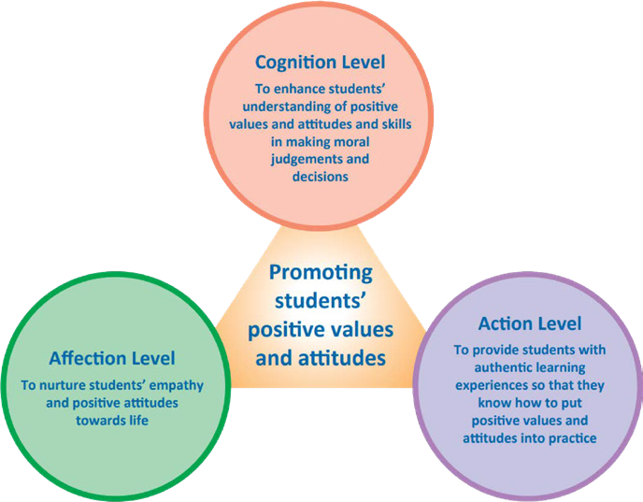  Figure 6A.1 Integration of Cognition, Affection and Action (p.10, Booklet 6A, Secondary Education Curriculum Guide (2017))  Diagram 3.2 Integration of Cognition, Affection and Action (3.3.2, Chapter 3A, Basic Education Curriculum Guide (2014)) | A text about motivational Paralympic athletes who beat the odds in their sporting career is identified for the S4 learning topic “The World of Sports”.  At cognition level, students are guided to identify the positive attributes (e.g. perseverance, resilience) of the athletes and analyse the reasons for their success.  For the affective domain, the teacher develops students’ empathy by asking them to put themselves in the shoes of the Paralympic athletes and empathise with the challenges faced by athletes with a disability.  To enable students to put positive values and attitudes into action, the teacher asks students to research on underprivileged groups in society and suggest how the Government can support the needy.
Provision of holistic and balanced learning experiences through integrating classroom learning, practical experience and learning environment | S2 students take part in a charity project on the theme “Charities and Helping Others” to promote students’ integrative use of language skills.
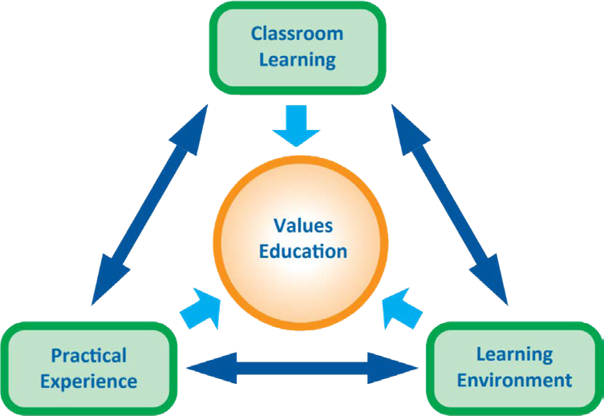  Figure 6A.2 Major Components for the Implementation of Values Education (p.11, Booklet 6A, Secondary Education Curriculum Guide (2017))  Diagram 3.3 Integration of Learning Elements in MCE (3.3.3, Chapter 3A, Basic Education Curriculum Guide (2014)) | The project starts with a talk by a social worker on underprivileged children who are deprived of education. Students then discuss the roles and responsibilities of the more fortunate ones to understand the importance of social responsibility.  Students are then asked to sign a “contract” to commit themselves to a series of fundraising events leading up to the “Jumble Charity Sale” to support children’s right to education.
  - A School Plan in Action – Nurturing Positive Values and Attitudes through English Sayings of Wisdom and the “Week of Hope”

A variety of learning activities can be organised throughout the school year to create an environment conducive to English learning and nurturing positive values and attitudes. Through hosting a school-based activity week (e.g. “Week of Hope/Gratitude/Kindness”), students are provided with holistic learning experiences and opportunities to apply what they have learnt in context. The plan below is an example illustrating how schools can structure learning activities throughout the school year and feature a “Week of Hope” to foster positive values and attitudes. The suggested activities are suitable for both primary and secondary schools. Teachers can select and adapt them to suit the needs of students of different capabilities.

A Plan for Nurturing Positive Values and Attitudes through English Sayings of Wisdom and the “Week of Hope”
Stage 1: Planning
Step 1: Identifying themes
Identify an overarching theme for the annual plan for promoting values education taking into consideration the school context (e.g. the school motto, major concerns, students’ needs).
Step 2: Looking for suitable SOW
Explore different types of SOW and compile a list of SOW which echoes the chosen theme(s).

Overarching Theme: Hope
Level | Sub-theme | Objective
S1 − 3 | Gratitude | To enable students to realise that they are leading a life filled with love and hope by appreciating the things and people around them
S4 − 6 | Staying optimistic and being proactive | To encourage students to stay optimistic and positive amid challenges and practise goal setting

S1 − 3 | Proverbs:  Count your blessings, Where there’s a will, there’s a way, All roads lead to Rome
S4 − 6 | Quotes by famous people:  “Learn from yesterday, live for today, hope for tomorrow.” (Albert Einstein), “Hope sees the invisible, feels the intangible, and achieves the impossible.”  (Helen Keller)

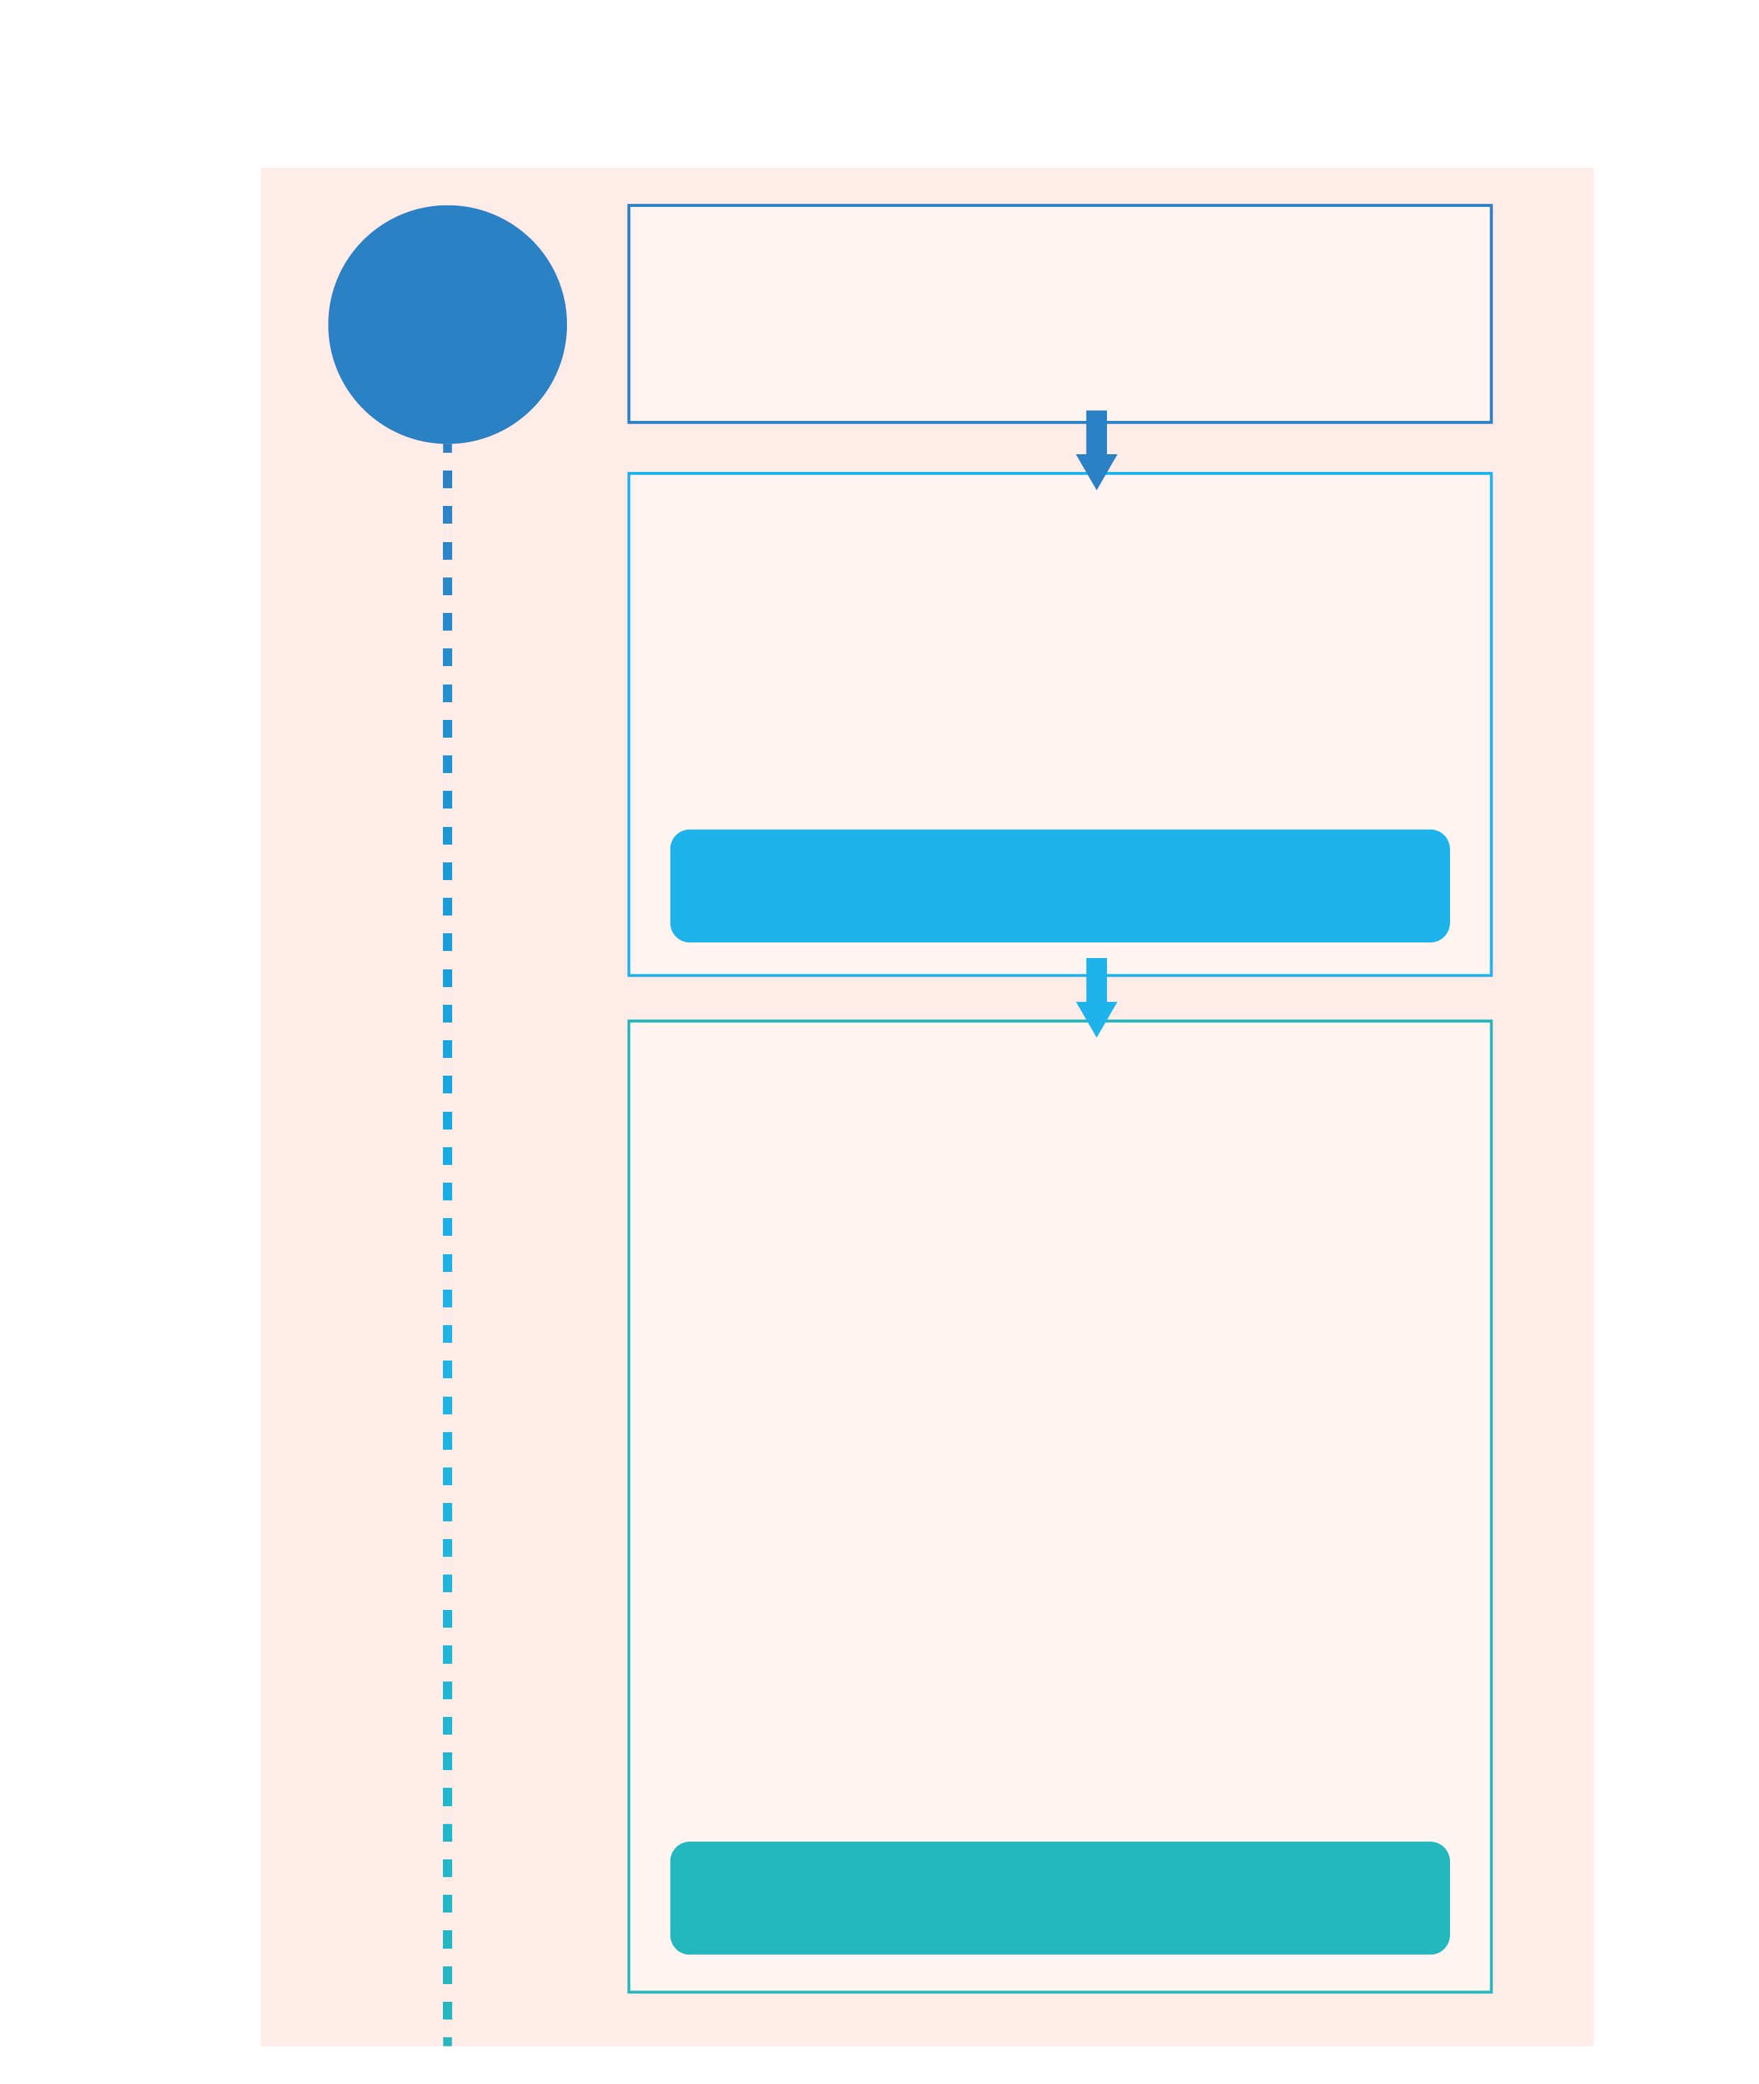
Step 3: Recruiting SOW Ambassadors
Recruit a team of SOW Ambassadors to support English teachers in organising the “Week of Hope” and other SOW activities throughout the school year.

Stage 2:

Stage 2:

Implementation
Implementation

Refer to Part 2 “Promoting Sayings of Wisdom in the English Language Classroom” for more suggestions.
Step 4: Infusing values education into
learning activities in the classroom

- Read a biography of an inspiring person
- Watch an animation conveying a positive message
- Design an infographic of an inspiring person
- Conduct research on the success story of an athlete
- Keep a “Hope” Journal

Step 5: Creating a conducive school
environment for promoting “Hope”
Make use of visual displays and leverage the efforts of different stakeholders to organise a wide variety of activities.
Visual display of the selected SOW
- Display posters/banners of SOW in the playground
- Organise a “Tree of Hope” board design competition
- Display SOW bookmarks designed by students
Promotion of reading related to SOW
- Organise thematic book displays in the school library (e.g. hope, inspiring people, overcoming challenges, self-help books)
- Arrange book sharing sessions in school assemblies
- Provide book recommendations on hope and other positive values by the principal, teachers, parents, students and alumni
Home-school cooperation
- Engage the PTA in running a parent-child “Hope Challenge” activity
- Organise a talk on “Mindfulness and Positivity” for parents and students

Refer to Part 2 “Promoting Sayings of Wisdom in the English Language Classroom” for more suggestions.
Refer to Part 3 “Creating a Language-rich Environment for Nurturing Positive Values and Attitudes” and Part 4 “Games and Teaching Aids” for more inspirations.

Stage 3: “Week of Hope”
Step 7: Week of Hope
Signature event of the school year – schedule the highlights/finals of different English activities/competitions for the week.
- Inter-class drama performance
- Song dedication by the school Campus TV
- Charity fair
- Mini games conducted by SOW Ambassadors during class teacher periods or recesses
- Polling for the “Tree of Hope” board design competition
Stage 4: Evaluation & Way Forward
Step 8: Concluding and reviewing
the SOW activities
Conclude and review the activities held in the school year and plan for the way forward.
- Create a photo album for the “Week of Hope”
- Arrange publications
- Acknowledge outstanding works and efforts
(e.g. printing students’ designs on school souvenirs, publishing winning entries of competitions)
Step 6: Organising service-oriented activities
Develop students into hope builders and get them to take actions to spread hope to others.
- Draw greeting cards with positive messages and send them to the children at hospitals
- Recruit students for voluntary services at animal rescue shelters
- Organise a donation for food banks

